SIMATS ENGINEERING
ASSESSMENT TOOL 1
COURSE NAME: Database Management Systems
COURSE CODE: CSA05

COURSE OUTCOME COVERED

CO2: Apply the relational model, relational algebra, SQL query structures, and views to solve database querying and data manipulation problems. (BL3, BL6)

Activity Tool : Analytical Problem Solving (High)
Assessment Tool Weightage: 40%

QUESTIONS
Q.N o | Question | Bloom's Level
1 | Given a set of relations and sample data, write SQL queries to retrieve specific information using joins and subqueries, and explain the logic used.  Bloom’s Level: BL3 – Apply | BL4 – Analyze
2 | Using relational algebra, formulate expressions to solve complex queries such as retrieving records that satisfy multiple conditions across relations.  Bloom’s Level: BL4 – Analyse | BL5 – Evaluate
3 | Given a real-world scenario (e.g., banking or student system), design a relational schema and construct appropriate SQL queries for data retrieval and updates.  Bloom’s Level: BL6 – Create | BL6 – Create
4 | Analyse a given SQL query with nested subqueries and predict its output, explaining each step of execution.  Bloom’s Level: BL4 – Analyze | BL6 – Create
5 | Compare different SQL approaches (joins vs subqueries) for solving the same problem and evaluate their efficiency.  Bloom’s Level: BL5 – Evaluate | BL4 – Analyze
6 | Design and implement views for a database system to provide restricted data access, and justify their use for security and abstraction. Bloom’s Level: BL6 – Create | BL5 – Evaluate
7 | Given a database schema, write relational algebra expressions and convert them into equivalent SQL queries, analyzing differences in representation.  Bloom’s Level: BL4 – Analyze | BL4 – Analyze
8 | Optimize a set of inefficient SQL queries by restructuring them using joins, indexing concepts, or views, and evaluate performance improvements.  Bloom’s Level: BL5 – Evaluate | BL5 – Evaluate
9 | Develop a complex SQL query involving grouping, aggregation, and nested queries to solve a real-world problem.  Bloom’s Level: BL6 – Create | BL6 – Create
10 | Given multiple relations, analyze the query requirements and decide whether to use views, joins, or subqueries, justifying your choice with reasoning.  Bloom’s Level: BL5 – Evaluate | BL5 – Evaluate

Code of Conduct:

Criteria | Level 4 (Exemplary) | Level 3 (Proficient) | Level 2 (Developing) | Level 1  (Beginning  )
Problem  Understandin g | Clearly interprets problem,  identifies all parameters and  requirements accurately | Understand s problem  with minor gaps | Partial understandin  g; misses key elements | Misinterpret s or unable to  understand problem
Method  Selection | Selects most appropriate  method/formul a with strong justification | Selects correct  method with minor errors | Inappropriate or partially correct method | Unable to select method
Solution Process | Logical, systematic  steps with correct  approach throughout | Mostly correct  steps with minor mistakes | Disorganized steps;  multiple errors | No clear process
Accuracy of Calculation | All calculations accurate; | Minor calculation errors | Frequent errors;  incorrect final answer | No valid calculations
I _____AKCHAYADEVI.G(192524501)_______________ (Name / Reg No) certify that this submission is my original work and that I have adhered to the guidelines specified for this assessment. I understand that any violation of academic integrity rules will result in disciplinary action.

Signature of the student:

RUBRICS FOR CALCULATION:

 | correct final answer
Interpretation of Results | Clearly interprets  results with units and  engineering relevance | Basic interpretatio  n with minor omissions | Limited or unclear interpretation | No  interpretatio n

- Given a set of relations and sample data, write SQL queries to retrieve specific information using joins and subqueries, and explain the logic used.

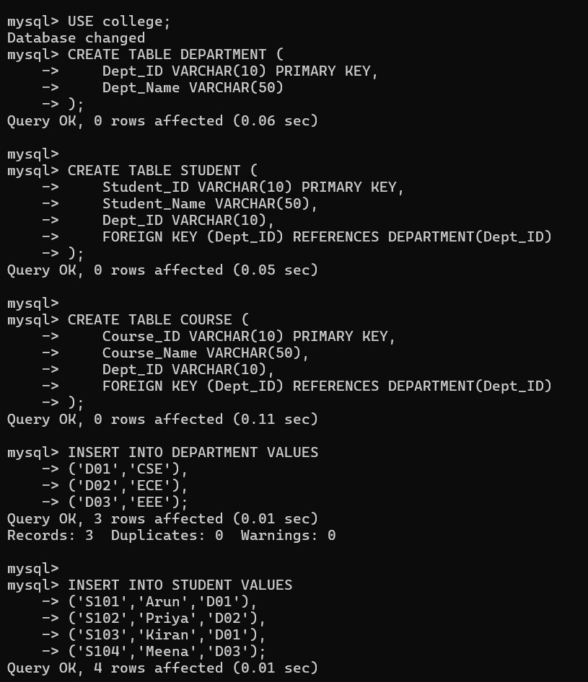

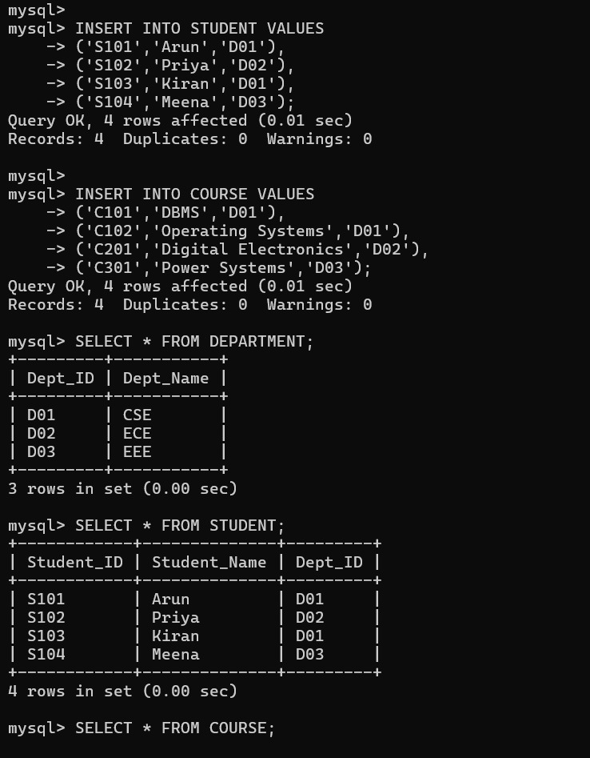
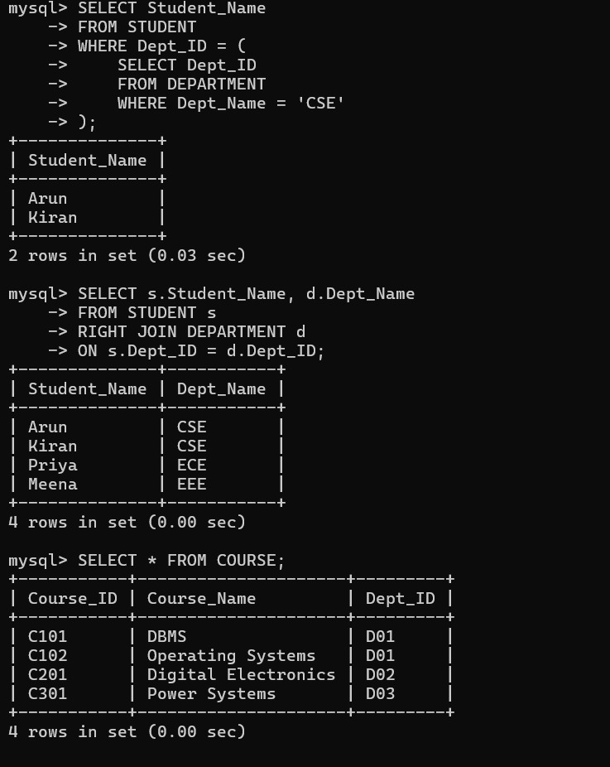

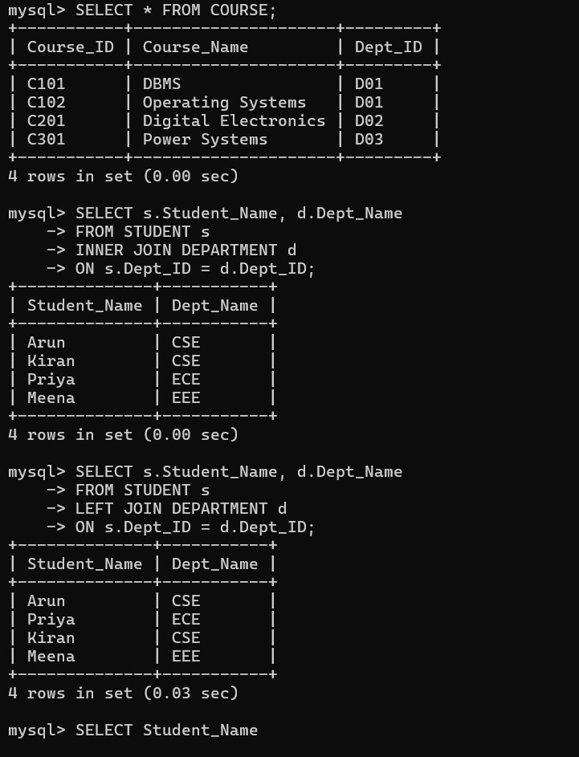

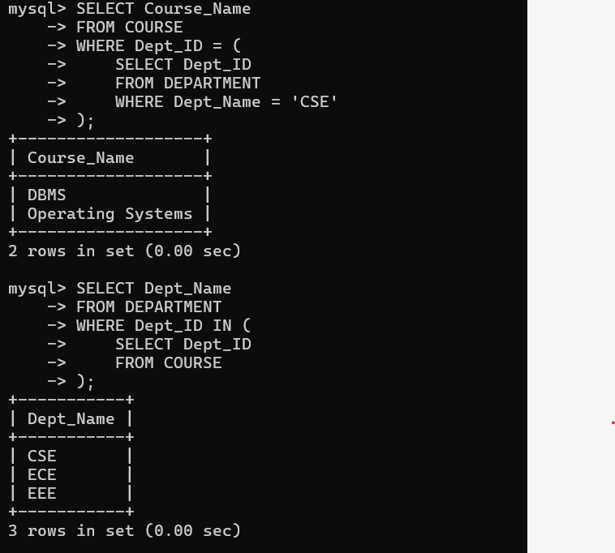

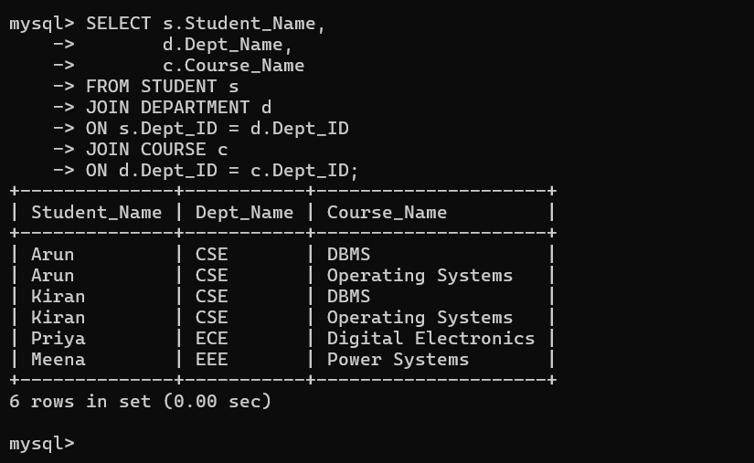

- Using relational algebra, formulate expressions to solve complex queries such as retrieving records that satisfy multiple conditions across relations.

Database Relations
STUDENT (Student_ID, Student_Name, Age, Dept_ID)
DEPARTMENT (Dept_ID, Dept_Name)
MARKS (Student_ID, Subject, Marks)
Query
Retrieve the Student Name of students who:
- Age is greater than 18
- Belong to the Computer Science department
- Have scored more than 80 marks

Step 1: Convert SQL Query
SQL Query
SELECT S.Student_Name
FROM STUDENT S
JOIN DEPARTMENT D
ON S.Dept_ID = D.Dept_ID
JOIN MARKS M
ON S.Student_ID = M.Student_ID
WHERE S.Age > 18
AND D.Dept_Name = 'Computer Science'
AND M.Marks > 80;

Step 2: Relational Algebra Notation
Select students whose age is greater than 18
R1​=σAge>18​(STUDENT)
Select the Computer Science department
R2​=σDept_Name=′Computer Science′​(DEPARTMENT)
Select students scoring more than 80 marks
R3​=σMarks>80​(MARKS)
Join STUDENT and DEPARTMENT
R4​=R1​ ⋈R1​.Dept_ID=R2​.Dept_ID​ R2​
Join the result with MARKS
R5​=R4​ ⋈R4​.Student_ID=R3​.Student_ID​ R3​

Project only the Student Name

πStudent_Name (
(
σAge > 18 (STUDENT)
⨝Dept_ID
σDept_Name = 'Computer Science' (DEPARTMENT)
)
⨝Student_ID
σMarks > 80 (MARKS)
)

Final Relational Algebra Expression

πStudent_Name (
(
σAge > 18 (STUDENT)
⨝ STUDENT.Dept_ID = DEPARTMENT.Dept_ID
σDept_Name = 'Computer Science' (DEPARTMENT)
)
⨝ STUDENT.Student_ID = MARKS.Student_ID
σMarks > 80 (MARKS)
)
Analysis
- Selection (σ) filters tuples satisfying the required conditions (Age > 18, Department = Computer Science, Marks > 80).
- Join (⨝) combines the STUDENT, DEPARTMENT, and MARKS relations using their common attributes (Dept_ID and Student_ID).
- Projection (π) retrieves only the required attribute (Student_Name) from the final result.
- The expression efficiently retrieves records that satisfy multiple conditions across different relations.

Result
The complex query is successfully represented using Relational Algebra by applying Selection (σ), Join (⨝), and Projection (π) operators. The final expression returns the names of students who are above 18 years of age, belong to the Computer Science department, and have obtained more than 80 marks

3.Given a real-world scenario (e.g., banking or student system), design a relational schema and construct appropriate SQL queries for data retrieval and updates.

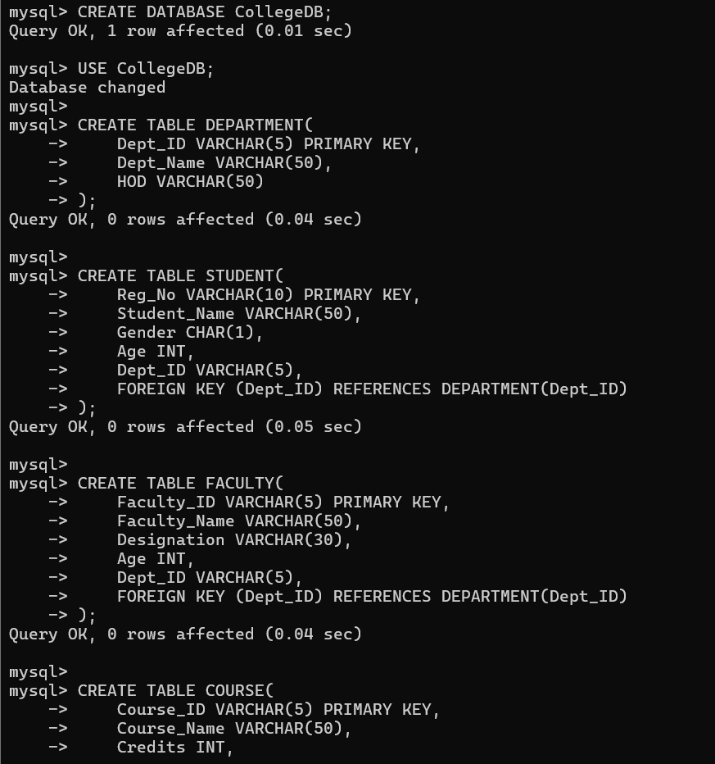

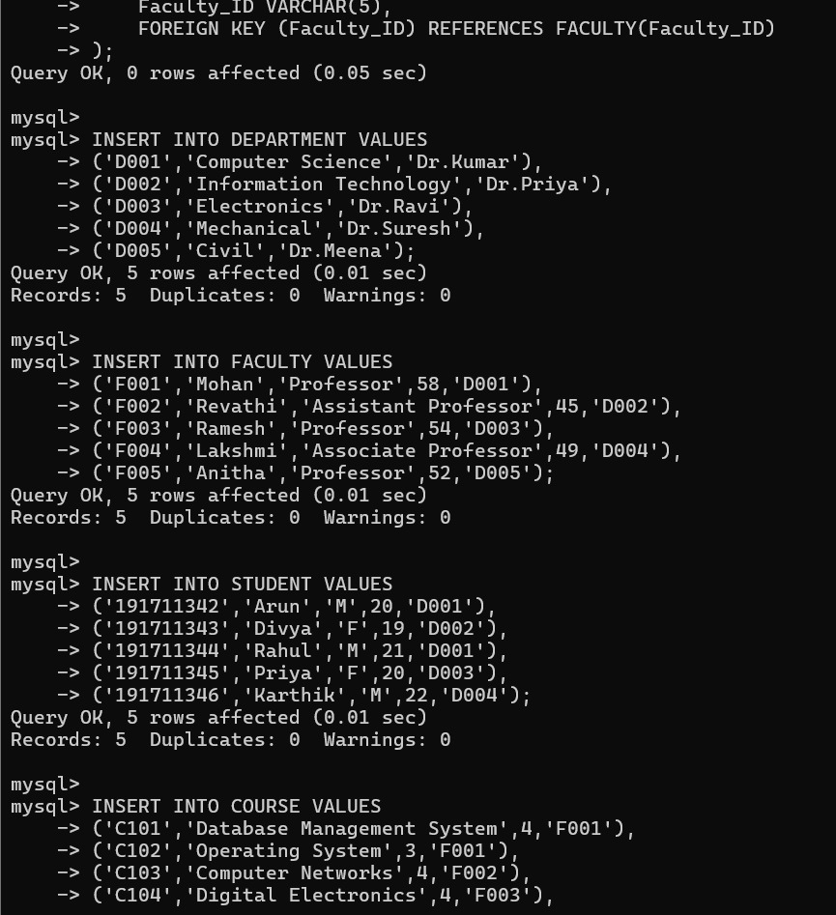

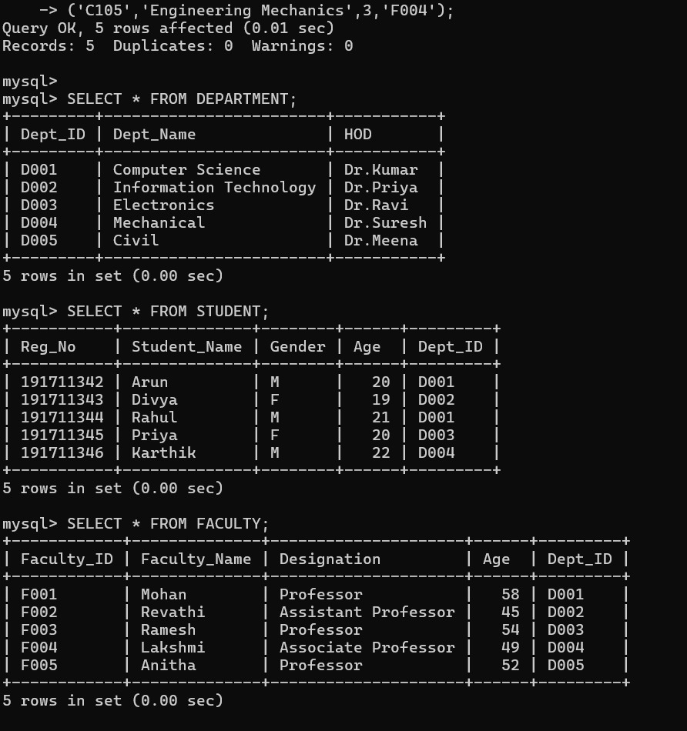

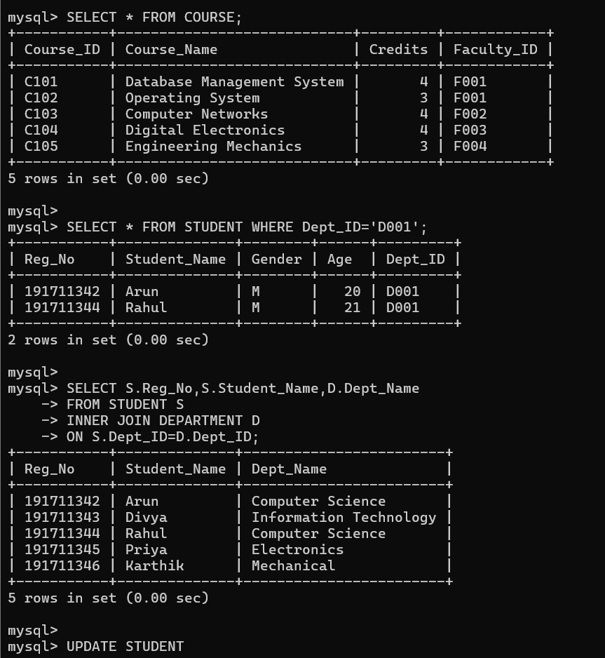

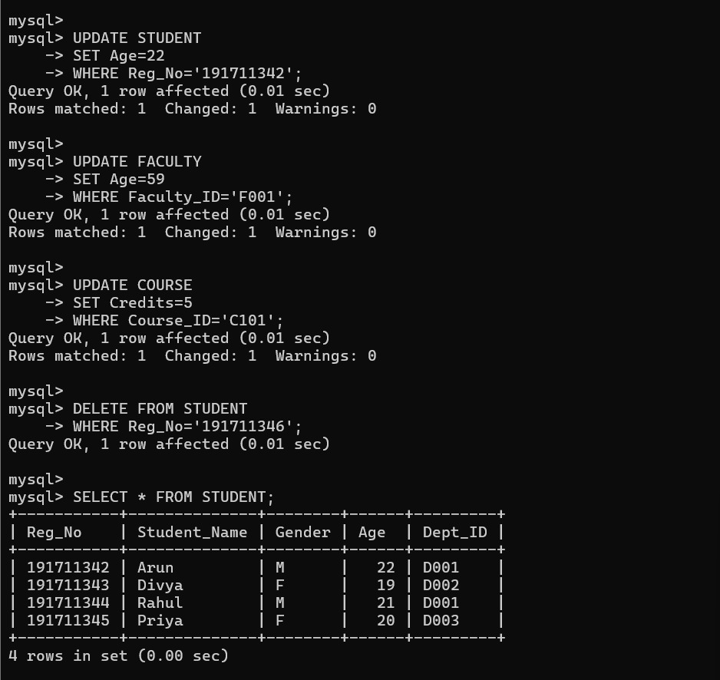

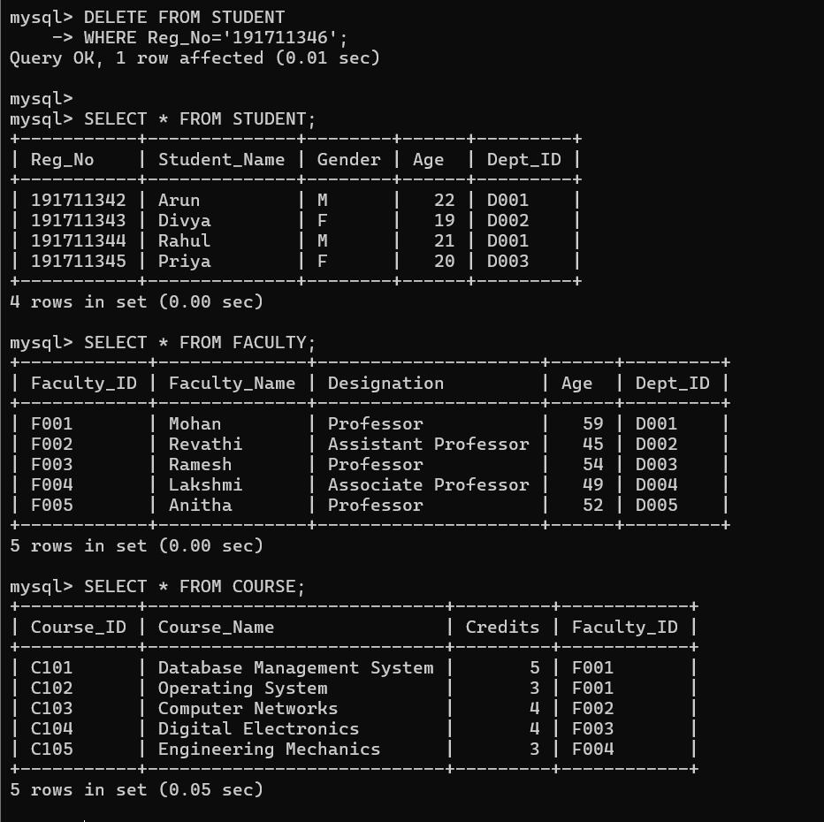

4.Analyse a given SQL query with nested subqueries and predict its output, explaining each step of execution.

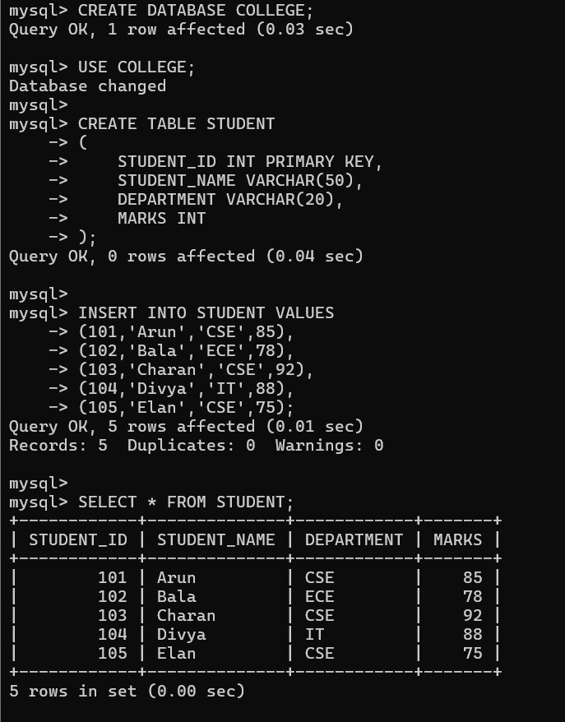

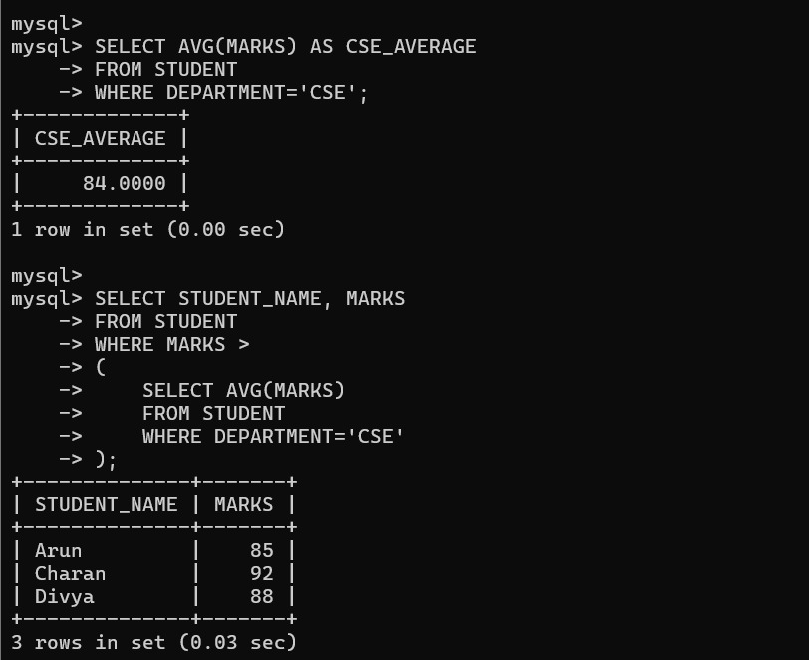

5.Compare different SQL approaches (joins vs subqueries) for solving the same problem and evaluate their efficiency

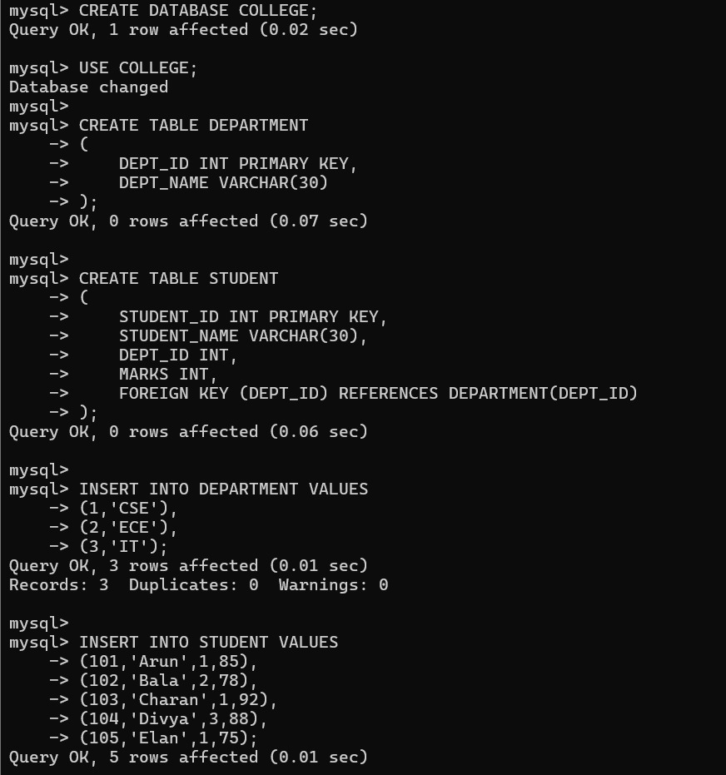

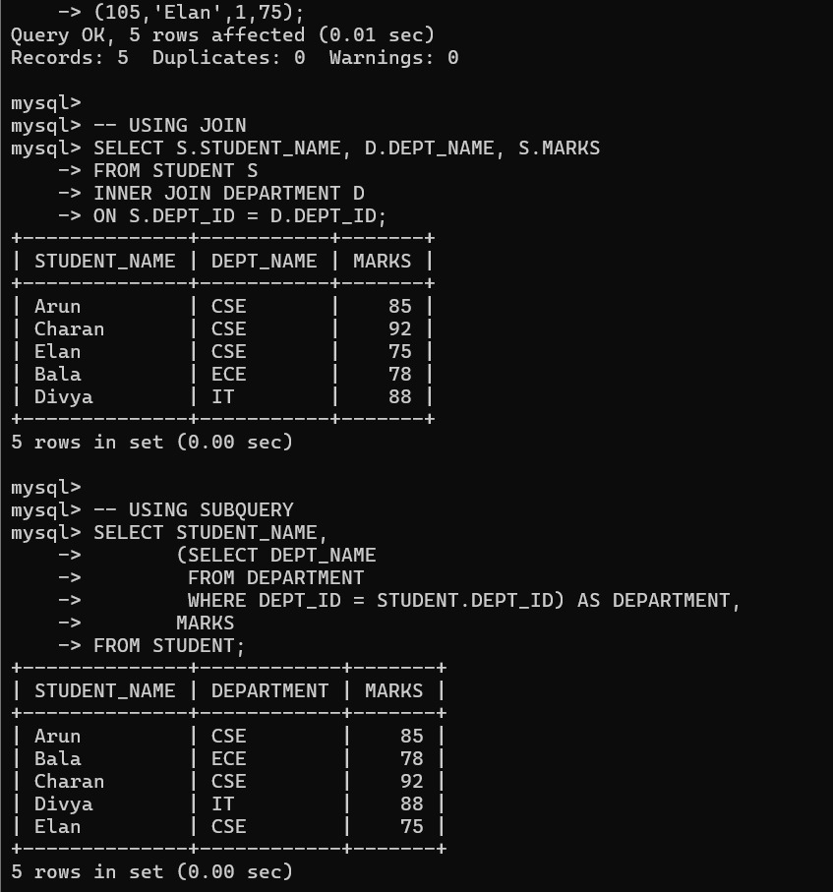

6.Design and implement views for a database system to provide restricted data access, and justify their use for security and abstraction.

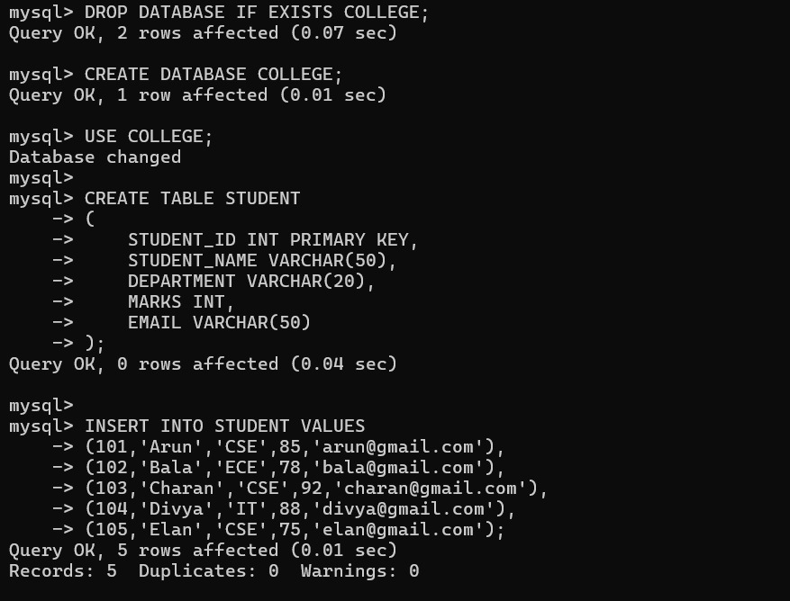

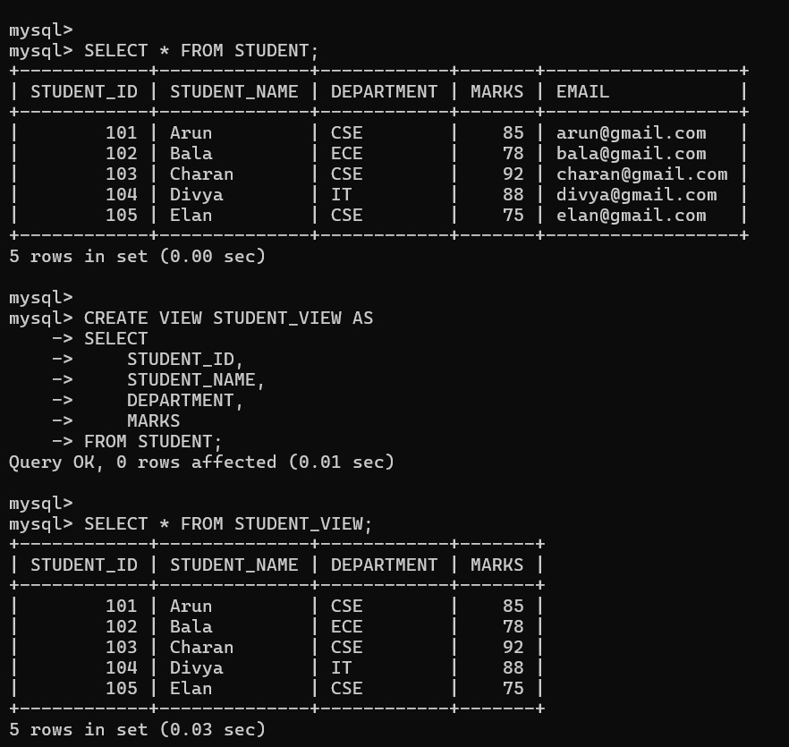

7.Given a database schema, write relational algebra expressions and convert them into equivalent SQL queries, analyzing differences in representation.
Relations
Student(StudentID, Name, Department)
Marks(StudentID, Subject, Marks)
Query
Retrieve the names of students who belong to the CSE department and scored more than 80 marks.
Relational Algebra Expression
π Name
(
σ Department='CSE' ∧ Marks>80
(
Student ⨝ Student.StudentID = Marks.StudentID Marks
)
)

Equivalent SQL Query
SELECT Student.Name
FROM Student
INNER JOIN Marks
ON Student.StudentID = Marks.StudentID
WHERE Student.Department = 'CSE'
AND Marks.Marks > 80;

Difference Between Relational

Algebra and SQL
Relational Algebra | SQL
Uses symbols such as π, σ, and ⨝ | Uses keywords like SELECT, FROM, WHERE, JOIN
Procedural query language | Declarative query language
Describes how to retrieve data | Describes what data to retrieve
Used for theoretical representation | Used for implementation in DBMS

RESULT
The Relational Algebra expression was successfully converted into an equivalent SQL query. Both produce the same output, but Relational Algebra uses mathematical notation while SQL uses English-like commands.

8.Optimize a set of inefficient SQL queries by restructuring them using joins, indexing concepts, or views, and evaluate performance improvements.

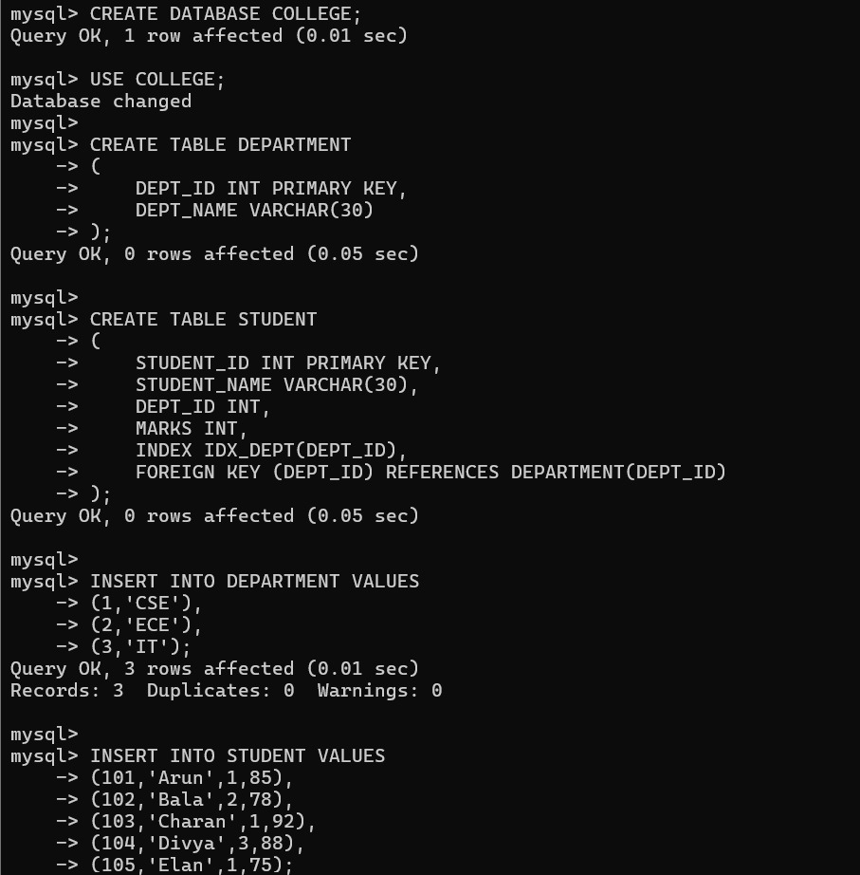

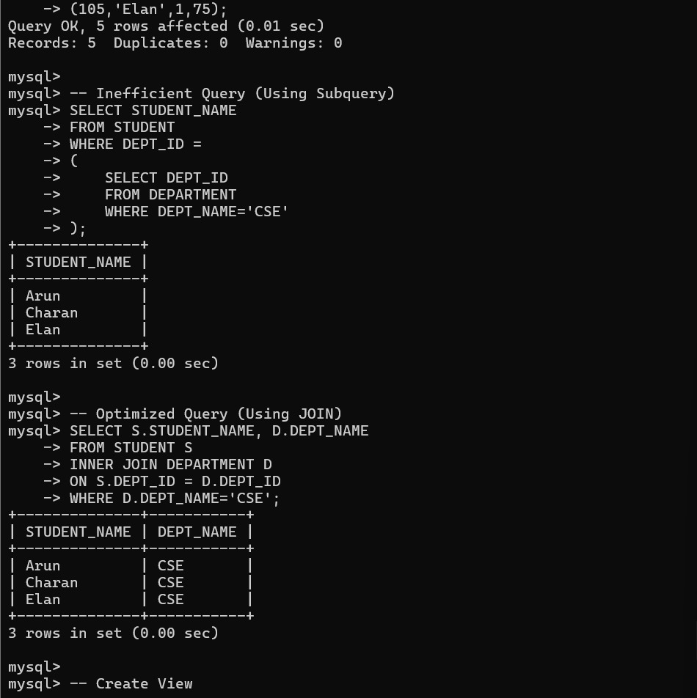

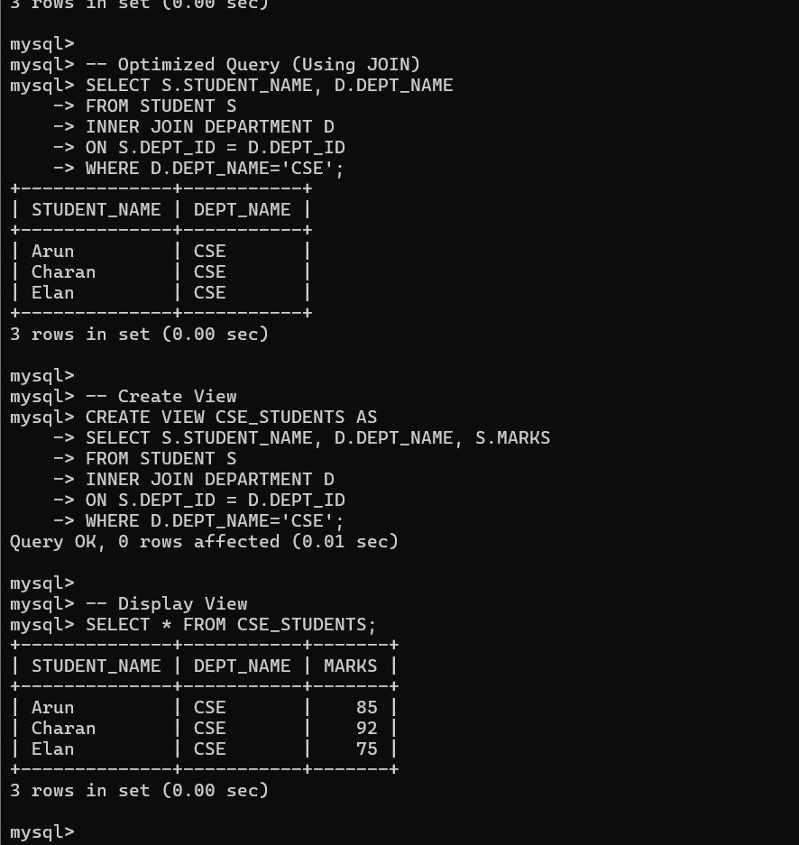

9.Develop a complex SQL query involving grouping, aggregation, and nested queries to solve a real-world problem.

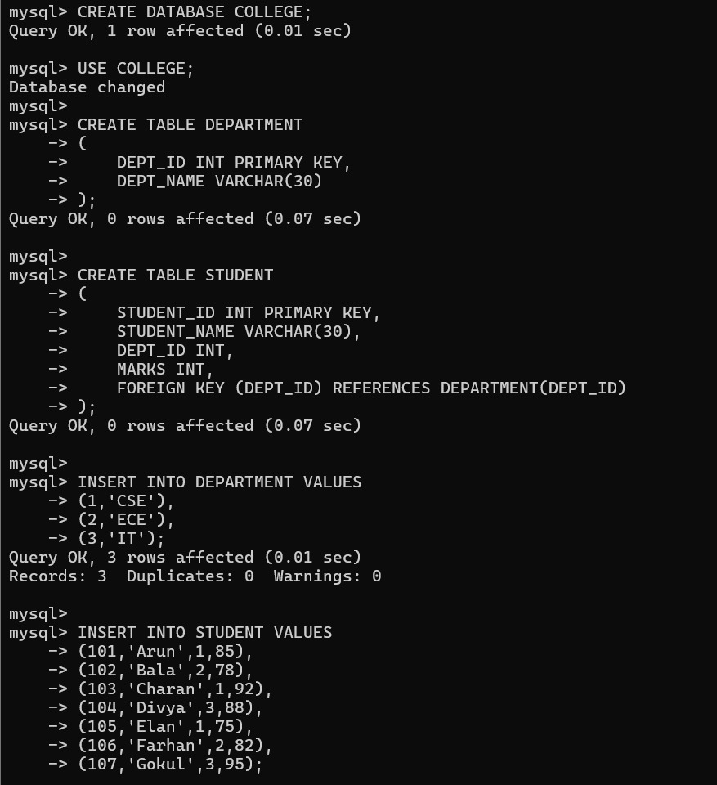

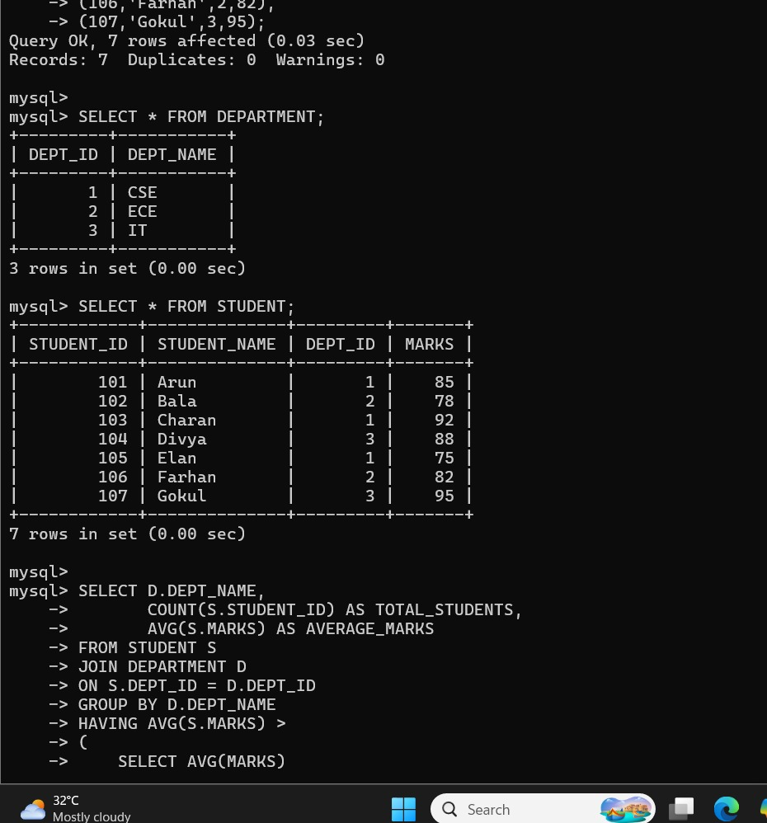

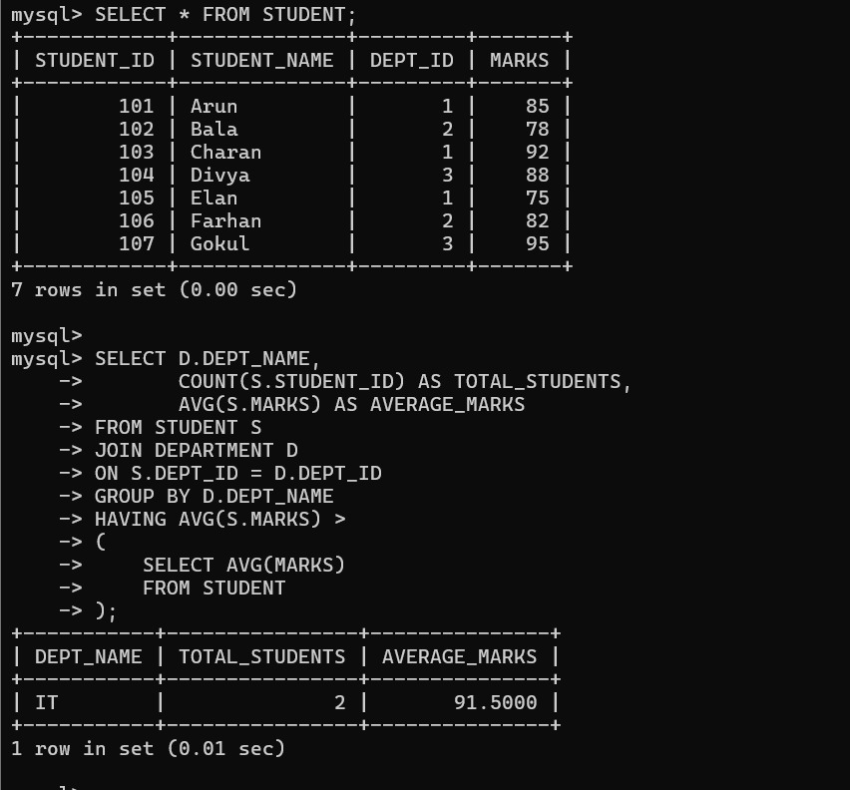

10.Given multiple relations, analyze the query requirements and decide whether to use views, joins, or subqueries, justifying your choice with reasoning.

